First Baptist Church Preschool Permission to Photo
We love to document the fun and learning that takes place at First Baptist Church’s Preschool and photos and videos truly capture the moment. While we want to use photos or videos to connect with preschool families, potential families and the community, we also want to be respectful of your child’s privacy. If parents give permission to release these photos, we will share them with you by posting them on the Preschool’s Facebook Page. Please indicate below how you would like any photos of your child to be handled, your decisions will be respected. Please note that in accordance with our Social Media Policy names will never be attached to any pictures of children. We look forward to sharing more about First Baptist Church’s Preschool with you.
Sharing on Social Media (Please select one option): (for the FBC Preschool Facebook Page, FBC Facebook Page, and Preschool Website)
_____I give permission for my child’s photos to be taken and shared on social media.
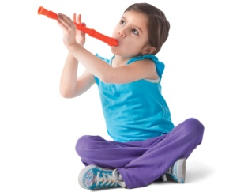
_____I give permission to share photos of my child on social media only if my child’s face is not shown.
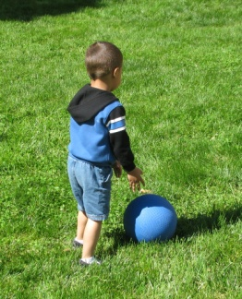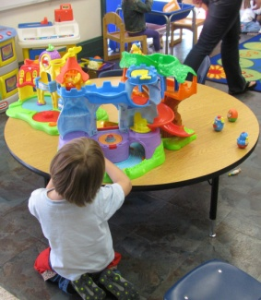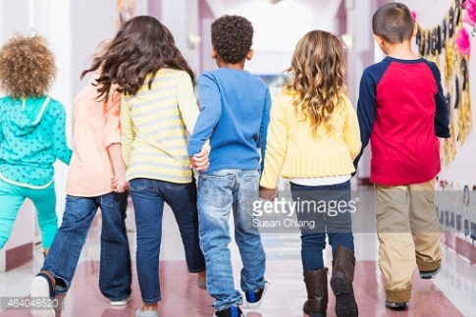
_____Please do not share any photos of my child on social media.
Newsletters and Other Print Media (Please select one):
______I give permission for my child’s photos to be used in the Preschool Newsletter, Church Newsletter, or other print media.
______I give permission for my child’s photos to be used in the Preschool Newsletter, Church Newsletter, or other print media only if their face is not shown
_____Please do not use my child’s photos in any print media.
Large Group Photos (Please circle yes or no): (Class Pictures, Field Trips, Christmas Program, Graduation)
Can we share a photo of your child on social media or the website if it is a picture of their whole class or multiple classes together?
Yes No
Can we share a photo of your child on the Preschool Newsletter, Church Newsletter or other print materials if it is a picture of their whole class or multiple classes together?
Yes No

______________________________ __________________________________ _____________ Child’s Name Parent’s Signature Date

